The University Of Azad Jammu & Kashmir

Student Name: Qurat Ul Ain Fatima
Roll No: 2024-SE-05
Course Title: Software construction & Development
Course Code: SE-3101
Course Instructor: Engr. Dr. Asma Javaid
Department: Software Engineering

Lab#03

Task 1: ATM Cash Withdrawal Sequence Diagram
Objective: To understand the sequence of activities involved when a customer withdraws cash from an ATM.

Step-by-Step Procedure
Step 1: Identify the Participants
First, identify all the participants involved in the ATM cash withdrawal process. These participants are:
- Customer
- ATM
- Bank Server
- Account Database
Each participant plays an important role in completing the transaction.
Step 2: Insert ATM Card
The customer inserts their ATM card into the ATM machine. The ATM reads the card information and identifies the customer's bank account.
Step 3: Enter PIN
After reading the card, the ATM asks the customer to enter their Personal Identification Number (PIN). The customer enters the PIN using the ATM keypad.
Step 4: Verify PIN
The ATM sends the card information and entered PIN to the bank server. The bank server checks whether the entered PIN is correct or incorrect.
Step 5: Check Account Details
After successful PIN verification, the bank server communicates with the account database to verify the customer's account information.
Step 6: Enter Withdrawal Amount
The ATM displays the available transaction options. The customer selects the cash withdrawal option and enters the amount they want to withdraw.
Step 7: Check Account Balance
The bank server receives the withdrawal request and checks the customer's account balance in the database. It verifies whether sufficient funds are available.
Step 8: Process Transaction
If sufficient balance is available, the bank server approves the transaction. The requested amount is deducted from the customer's account.
Step 9: Dispense Cash
After receiving transaction approval, the ATM machine processes the request and provides the requested cash to the customer.
Step 10: Complete Transaction
After dispensing the cash, the ATM returns the customer's card and provides a transaction receipt. The withdrawal process is now completed.
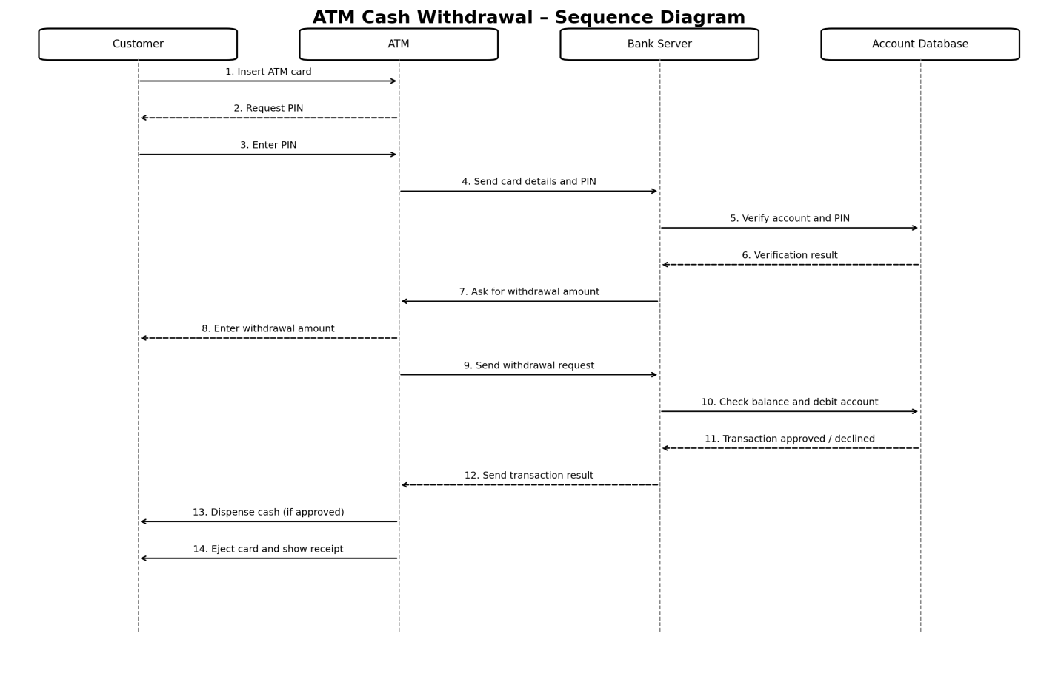

Task 2: Online Ticket Reservation System
Objective: To understand the sequence of activities involved in reserving tickets through an online ticket reservation system.

Step-by-Step Procedure
Step 1: Identify the Participants
First, identify the main participants involved in the online ticket reservation system:
- Customer
- Website / Application
- Reservation System
- Database
- Payment Gateway
These participants work together to complete the ticket reservation process.
Step 2: Open Website
The customer opens the online ticket reservation website or application. The system displays the available events, movies, or travel options.
Step 3: Select Event
The customer selects their desired event, date, time, and number of tickets. The selected information is sent to the reservation system.
Step 4: Check Seat Availability
The reservation system receives the customer's request and checks whether the required seats are available for the selected event.
Step 5: Verify Availability
The reservation system communicates with the database to retrieve the latest seat availability information. The database returns the available seat details.
Step 6: Display Ticket Details
After checking availability, the website displays the available seats, ticket prices, and booking details to the customer.
Step 7: Confirm Reservation
The customer selects the required seats and confirms the reservation. The system collects the necessary customer information to proceed with the booking.
Step 8: Process Payment
The reservation system sends a payment request to the payment gateway. The customer is asked to provide the required payment information to complete the transaction.
Step 9: Verify Payment
The payment gateway checks the submitted payment information and processes the transaction. After verification, it sends the payment status to the reservation system.
Step 10: Confirm Booking
If the payment is successful, the reservation system updates the database and changes the reservation status to confirmed. The selected seats are marked as booked.
Step 11: Generate E-Ticket
Finally, the system generates an electronic ticket (E-Ticket) containing the booking details. The customer receives the ticket and booking confirmation through the website, application, or email.
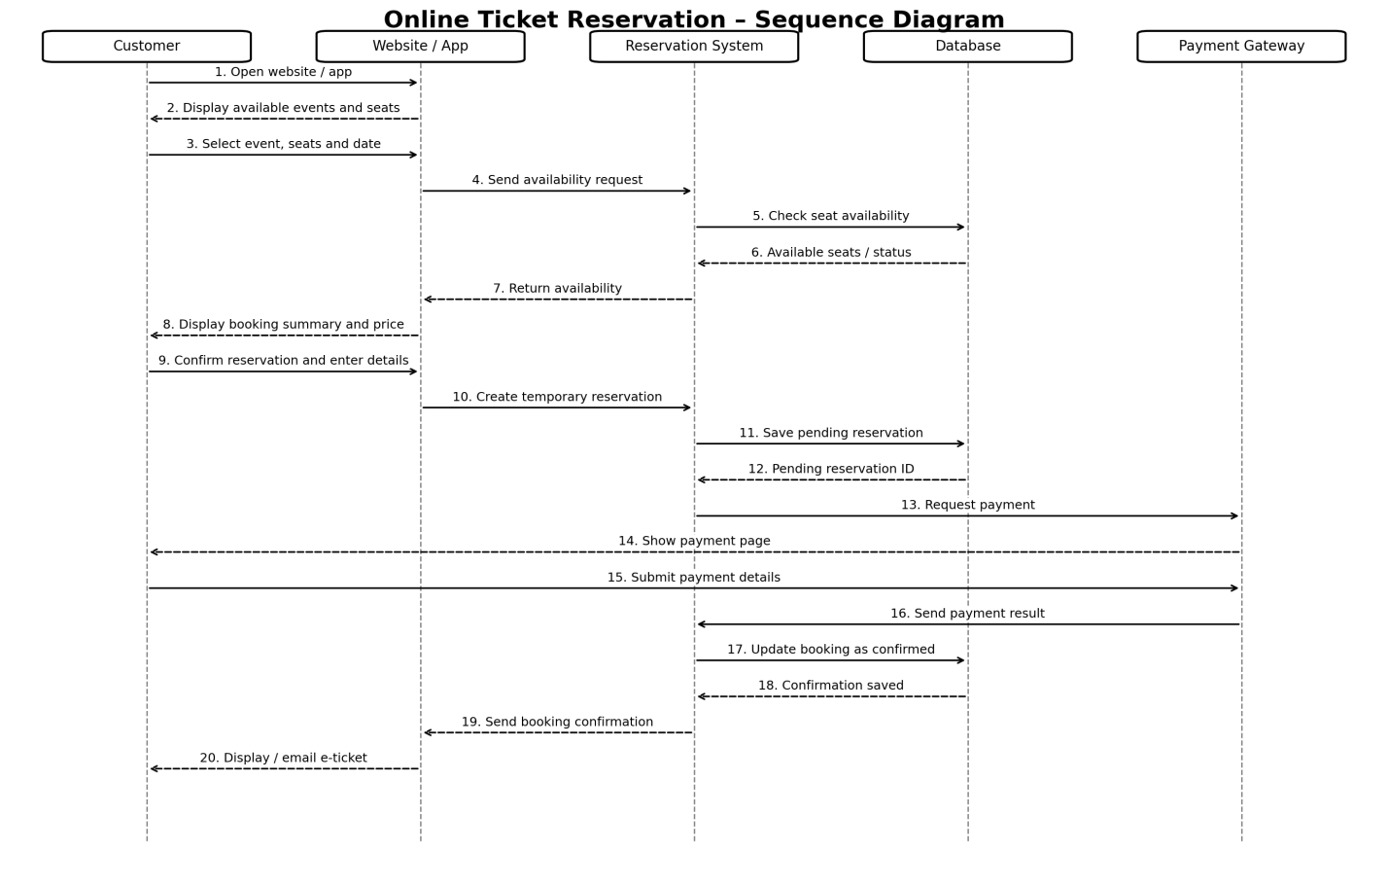

Conclusion
In this lab, two sequence diagrams were studied.
- ATM Cash Withdrawal System: Explains how a customer withdraws cash from an ATM through card verification, PIN verification, balance checking, and transaction processing.
- Online Ticket Reservation System: Explains how a customer selects an event, checks seat availability, makes payment, and receives a confirmed electronic ticket.

